**Access Statement**

**Our website**

We have carefully selected font sizes, colours and backgrounds and have ensured there are no flashing images.

Our website is compliant with the Web Content Accessibility Guidelines (WCAG) so it can be viewed on a range of different screen sizes and mobile devices.

An access toolbar features a screen reader and provides visitors with the opportunity to change the font size, format and contrast.

Our contact details and full address, along with a map showing our location are available.

**Getting to The Sight Centre**

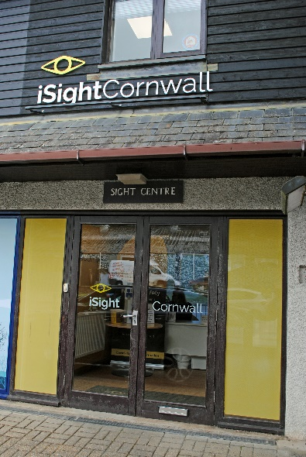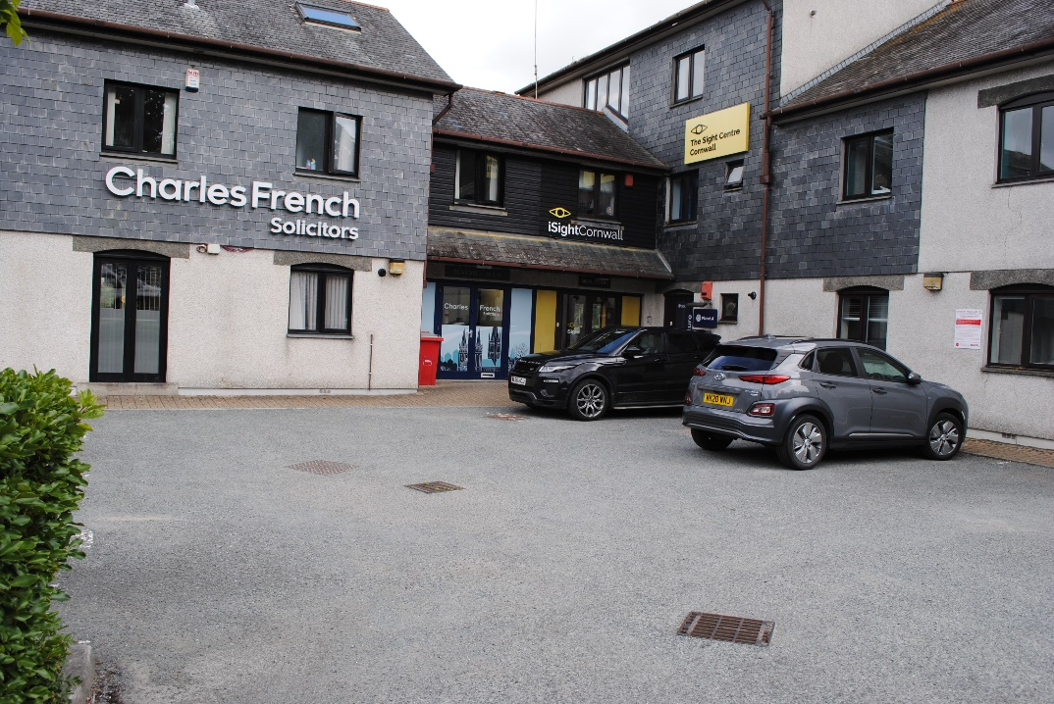

There is clear, easy to read signage to The Sight Centre and large signage on the building. All pedestrian routes within the car park are level, well-maintained and free from obstructions, including free-standing signage.

**Parking**

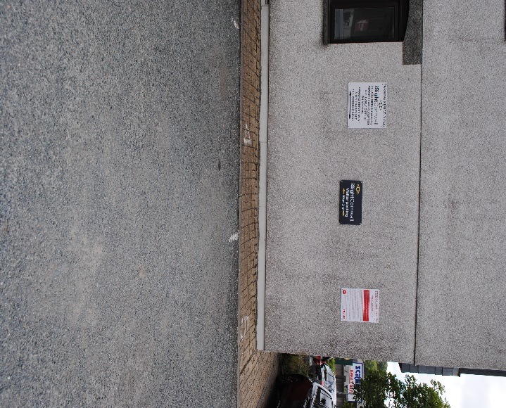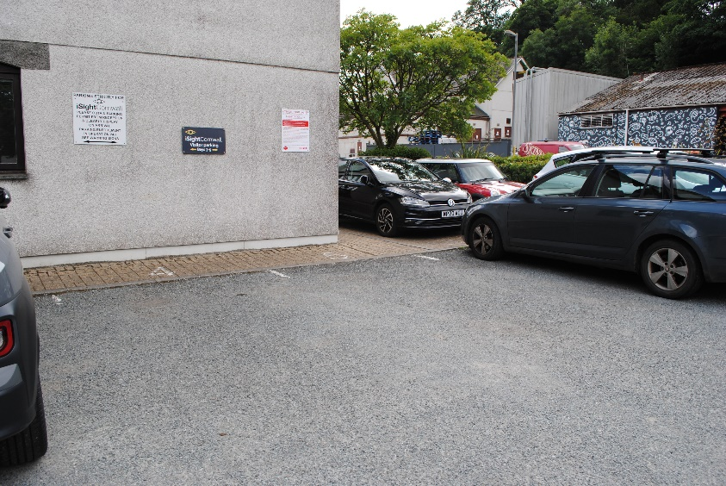

We have three parking bays numbered 4, 5 and 6 outside the main entrance to the Centre. The bays are clearly signposted as you enter the general car park.

There is an area for a more convenient drop-off close to the front entrance for people with mobility impairments. Once accompanied into the Centre please park vehicles in one of the designated bays.

The bays are not wide enough for car doors to be fully opened to allow disabled drivers and passengers to transfer to a wheelchair parked alongside, so please come to reception on arrival for assistance.

Please collect a free parking permit from our reception to place in your vehicle to avoid parking charges.

**Entering The Sight Centre**

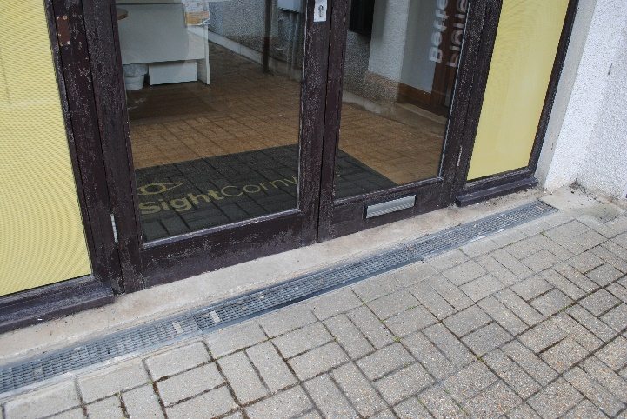

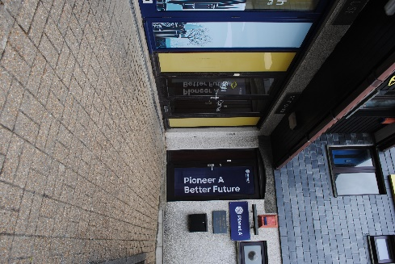

There is level access from all our parking bays and a low-level slope to the Centre entrance.

There are two glazed doors to the Centre entrance. They are easy to identify, light weight, with good signage.

The easy action lever handle of the left door ensures accessibility for most customers, both doors can be opened for wheelchair users and mobility aids access

Contrasting markings are on both doors to prevent customers walking into them.

**Within The Sight Centre**

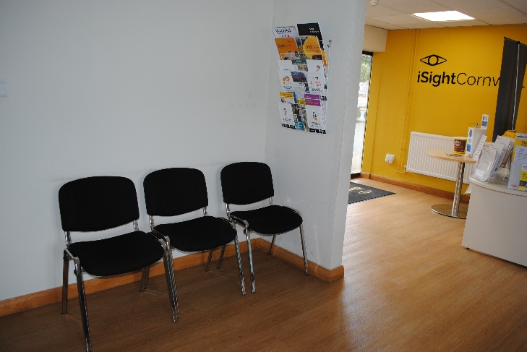A large room with a sign and a table. The room has a reception desk and a table in front of it with leaflets and information.


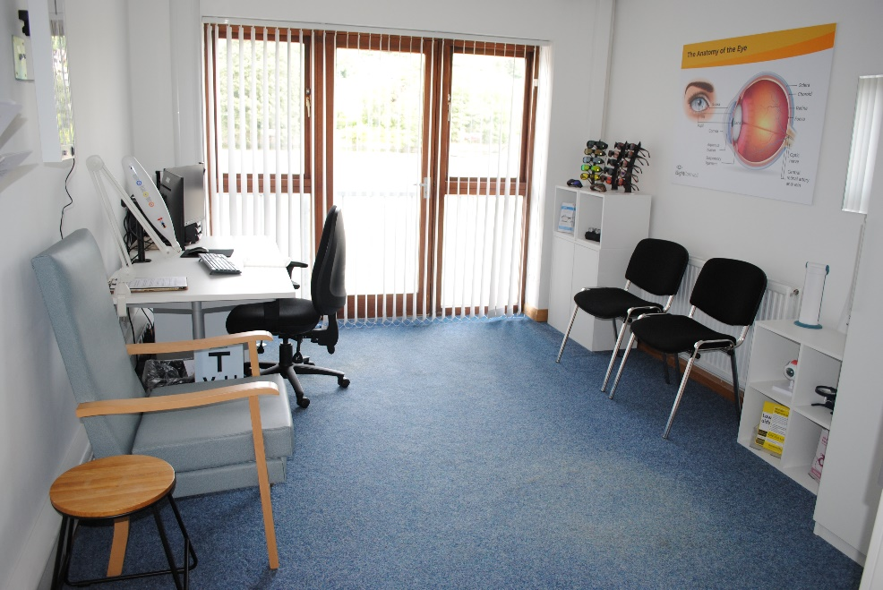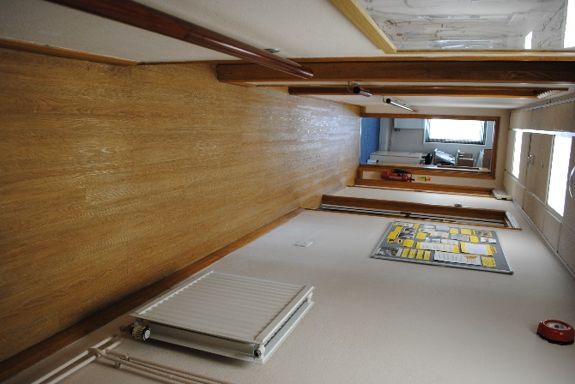

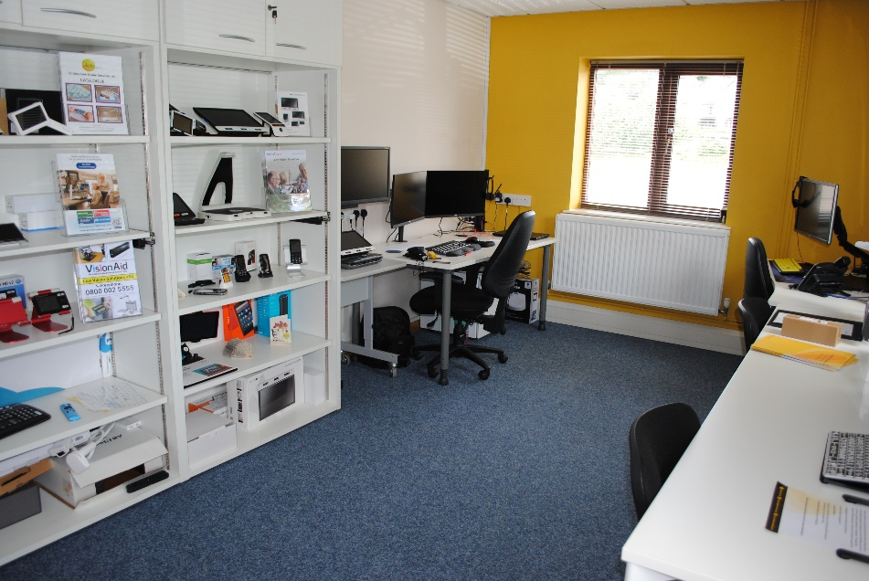

The reception area is spacious, with plenty of room to manoeuvre around. A door entry bell alerts us that visitors have arrived at the Centre.

Visitor services are available on the ground floor only.

The flooring is level with hard-wearing laminate and carpet used throughout. The unisex visitor WC toilet is fitted with linoleum for hygiene reasons.

Internal doors within the public area of our building have a width greater than 750mm.

The Centre makes the most of natural light and supplemented with artificial lighting in the corridor and the ground-floor WC toilet.

Signs, routes and entrances and exits are well-lit and can easily be seen and navigated.

We have a range of seating available in our waiting area and appointment rooms.

We can move furniture to accommodate different people’s needs. There is space for a wheelchair user to pull up alongside a seated companion. Assistance dogs are very welcome in our Centre.

**Toilet facilities**

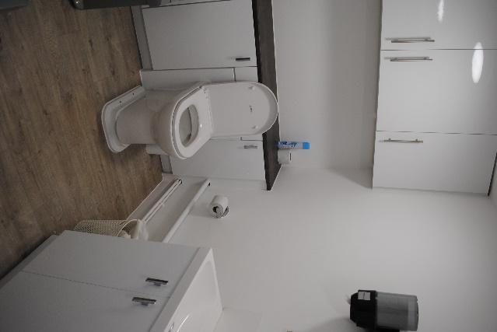

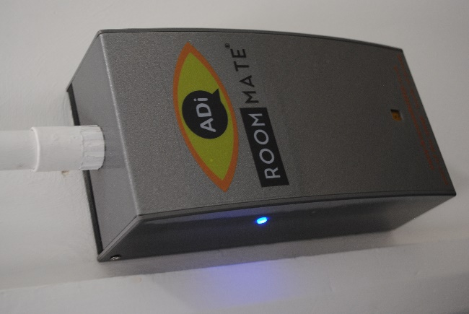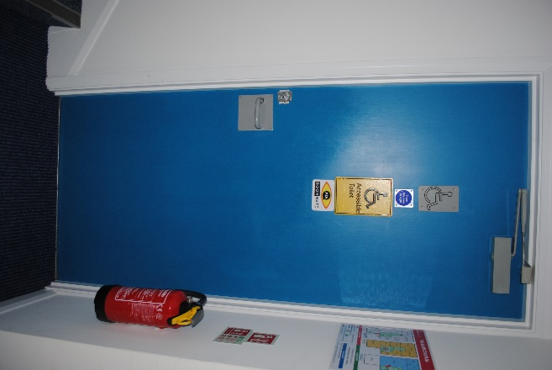

The building does not have an accessible toilet but the visitor toilet and washing facilities on the ground floor have some accessible features. The door is 900mm wide and there is a small circulation space between the toilet and the door. There is a raised toilet with a 670mm space to the left-hand side (when looking at the toilet from the door) to allow for transfer from a wheelchair.

The bathroom features a RoomMate which gives an audio description of the toilet area.

**Emergencies including fire safety and evacuation**

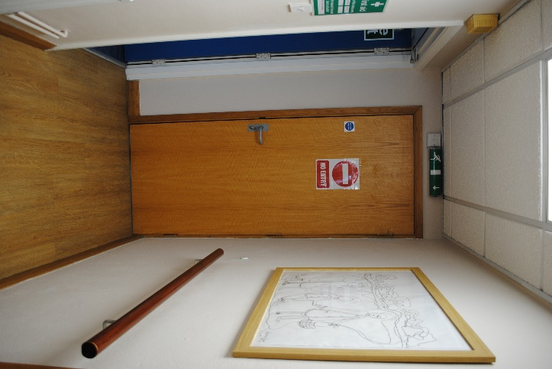

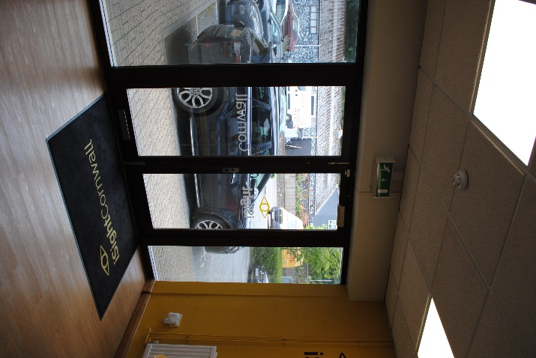

We have a fully equipped first aid kit, which is stored alongside a sign displaying the names of the trained staff.

We have a fire risk assessment and process which includes:

* Assessing risks to disabled people, whether staff or visitors, while on our premises.
* Evacuating disabled people from the building.
* Regularly checking fire exit signage, evacuation routes, alarm system and drill.
* Training our staff team so they are prepared in the event of the fire alarm sounding, in terms of their roles and responsibility.

We also give all staff the opportunity to create a Personal Emergency Evacuation Plan, detailing specific ways in which we can support their evacuation from the premises in the event of the fire alarm sounding.

The Centre features fire exit signage which highlight the step-free access routes.

**Sight Centre Map**  
